COMPANY: FAMILY FLOAT

Whitewater Rafting Website Planning Document

1. Site Purpose
The purpose of this website is to expand reach, accessibility, and information to families who are interested in learning more about whitewater rafting and how it can be a safe and fun family adventure.

2. Target Audience
The target audience is families of all ages, increasing safety and accessibility to a younger audience. Targeting families with children between the ages of 8-18, as well as adults aged 18-50. This would be an excellent option for beginner white water rafters, or hesitant thrill seekers. Our river courses are ideal for family reunions, small and large friend groups, and summer youth camps. Parents are likely to prioritize the safety of their children and will have questions about how this sport is or is not safe as a family activity and online is a great place to source this information.

3. Logo Selection

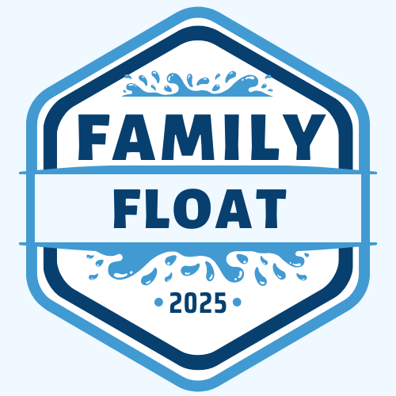

4. Color Palette
The chosen color palette consists of the following hex codes:
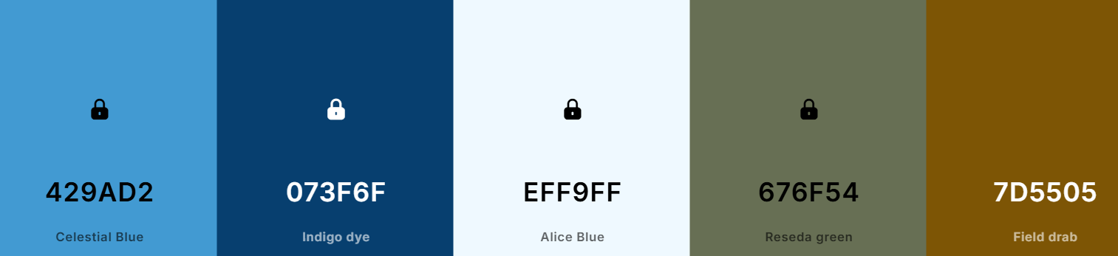
- Primary Color: #429AD2
- Secondary Color: #073F6F
- Accent 1 Color: #EFF9FF
- Accent 2 Color: #676F54
- Accent 3 Color: #7D5505
Palette generated using Coolors:
https://coolors.co/429ad2-073f6f-eff9ff-676f54-7d5505

5. Typography
Selected fonts from Google Fonts:
- Fuzzy Bubbles
- Comic Relief

